**PAS**

**To:** Dr. Matt Bohm

**From:** PAS

**Project:** Plasma Arc Speaker

**Subject:** Concept Variant 10

**Date:** March 4, 2011

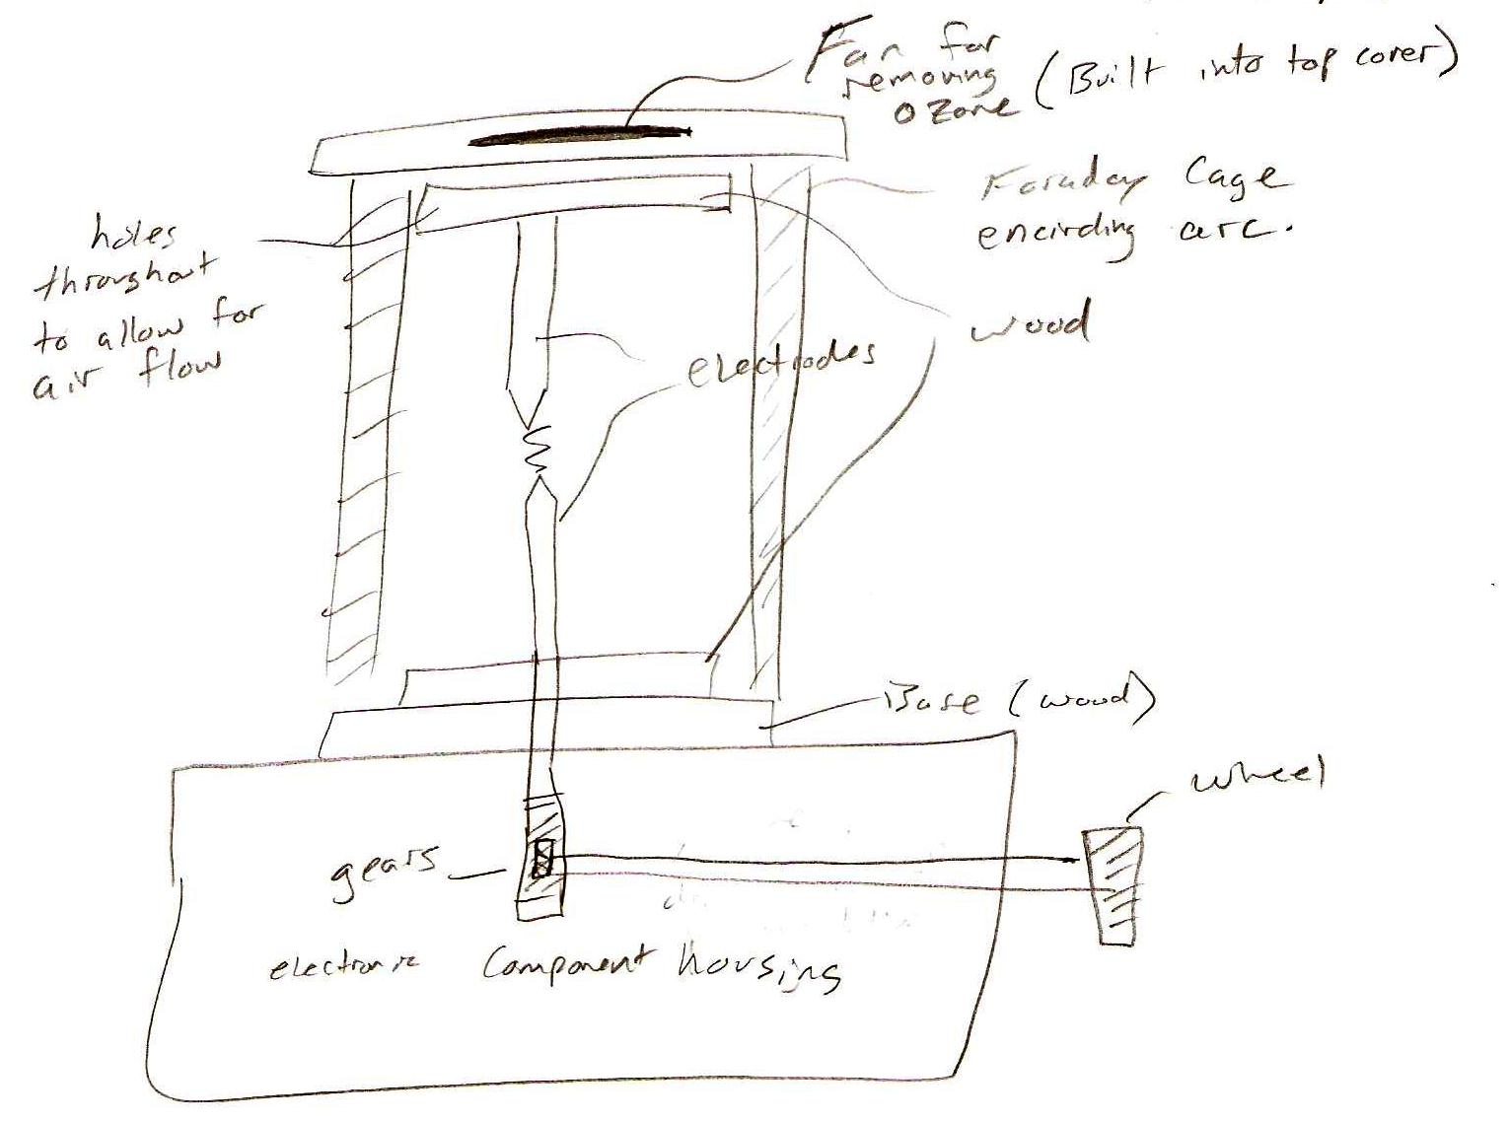

CV 10 consists of an electrical component housing on the bottom.  The electrodes are located vertically above the housing and are insulated with wood or a ceramic material on the top and bottom, as well as being surrounded by a Faraday cage.  The top electrode support has a fan for removing ozone created by the arc, if it creates large enough quantities of ozone.  The bottom electrode is connected to a rack and pinion setup which lowers and raises the electrode when turned with the hand wheel.